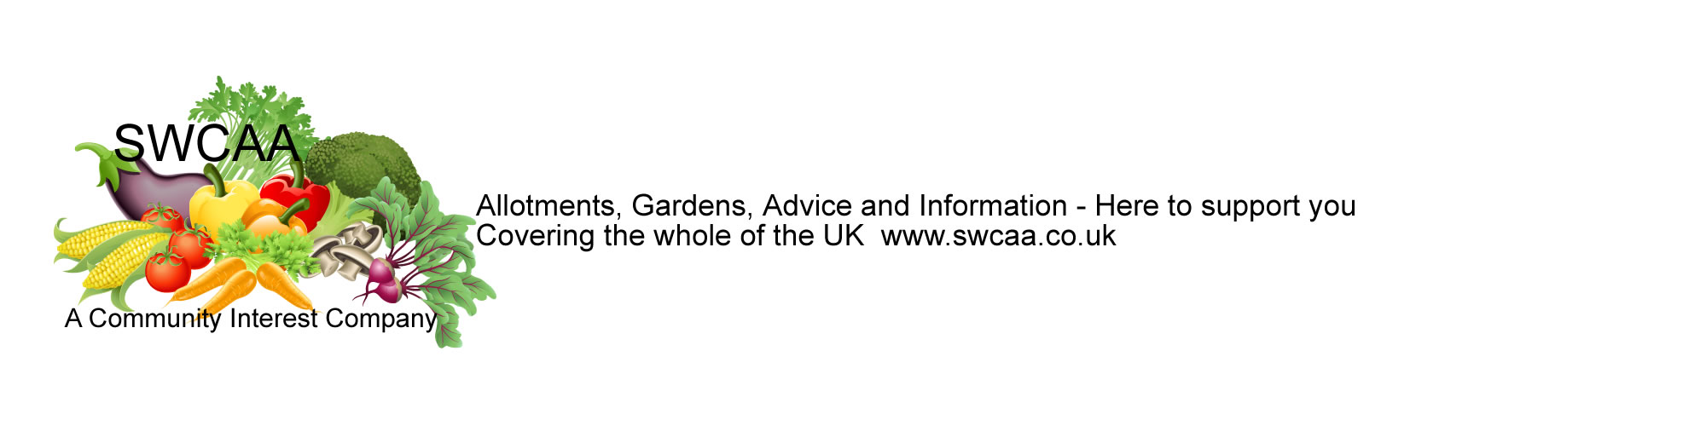
SWCAA MEMBERSHIP RENEWAL LETTER

Dear SWCAA Member
We are writing to let you know that your membership with SWCAA is up for renewal. We hope that you have been happy with your insurance cover and that you will take this opportunity to renew with us again this year. Your £10 includes Public and Product Liability Insurance.
You can now pay via BACS if you wish to use this service, payments will only be processed on receipt of an e-mail or phone call from you stating your name or payment reference, date and amount paid and also on receipt of your membership form or renewal list either by post or email. Account number 91683225 Sort code 40-09-13
Best wishes
Ayesha Hooper
Director/CEO
--------------------------------------------------------------------------------------------

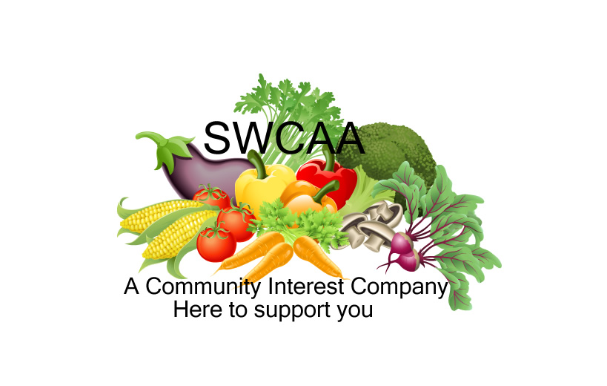 | SWCAA RENEWAL SLIP

I would like to renew my (please tick) Public Liability (£10) Employers Liability (£15)
Please note Employers Liability is available to members only

Membership Number SWCA ……. Cheque/PO Number……………..Amount to Pay £………………
Please make cheques payable to SWCAA and write your membership number on the reverse of your cheque/PO
send to 22 Miller Crescent, Barnstaple, EX32 7DZ
Please confirm your contact details below.
Title: Mr Mrs Miss Ms

Name: ………………………………………………………………………………………………………………

Address: ……………………………………………………………………………………………………………

……………………………………………………………………………………………………………………….

……………………………………………………………………………Postcode………………………………..

Phone Number: …………………………e-mail …………………………………………………………………..
(please provide an e-mail address if you can so we can e-mail you your confirmation, thus saving resources)
Date of Renewal (find this on your confirmation receipt) ……………………………………..........web2018
If you do not wish to renew please let us know so we can amend our records accordingly 